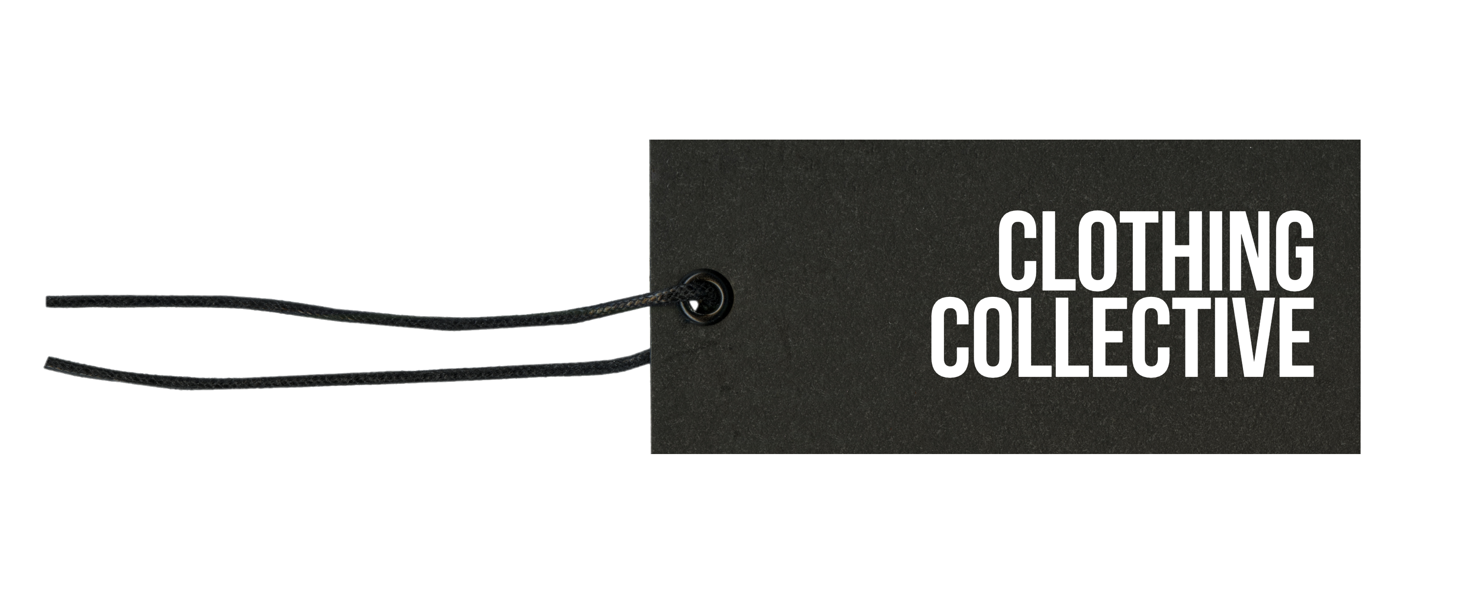

Complaints Policy

Whilst we make every effort to meet peoples’ expectations, circumstances may arise where an individual has a concern and wishes to bring this to our attention. We will take all reasonable steps to resolve the situation, in everyone’s best interests.

For very serious concerns, such as individual’s safety being placed at immediate risk, take such action as is appropriate. For example, by calling the emergency services.

**INFORMAL COMPLAINTS**

Anyone who has a concern should initially raise this with a member of our team at the time, as this enables us to respond and deal with an issue quickly.

We will seek to resolve this and meet any reasonable expectations the individual may have, ideally to his or her satisfaction. If unable to, make a note of:

* The complainant’s name and contact details, unless he/she is unwilling.
* The nature of his/her concern and anything that he/she wished to be done about it.
* The circumstances surrounding the complaint, including when, where, any action that was taken and the details of others who were present/involved.

Advise the complainant that their concern will be passed to the trustees*.*

**FORMAL COMPLAINTS**

Where an individual wishes to make a formal complaint, he/she should write to, or e mail:

Personal For: info@clothingcollective.org

To help resolve the complaint as quickly and effectively as possible, the individual making the complaint should do so as soon as possible and should include in it:

* Name, organisation (if relevant), address, telephone number and e mail.
  + If you do not wish to be contacted in a particular way, please let us know and we will of course respect this.
* As much information as possible, such as what happened, where, when (date/time), who was present and any action taken, and by whom.
* What it is you felt to be unsatisfactory.
* What you believe should be done to address your concern.

Receipt will be acknowledged, if at all possible within 7 working days. The complaint will then be investigated. If necessary, specialist advice will be sought. Where clarification or further information is felt to be necessary, the trustees will contact the person complaining to request this.

A response will be sent within 14 working days. If this is not possible, a holding reply will be sent after 14 days advising when we estimate the investigation will be completed. The complaint response will explain our findings and what action we will be taking/have taken, subject to the constraints of the Data Protection Act, which will almost certainly not allow us to disclose sensitive personal information.

If the complainant is not satisfied with the response, he or she may appeal the decision, by writing to the Chair:

Personal for: *info@clothingcollective.org*

The appeal should be specific about why the individual feels the decision made was wrong and provide the facts and information necessary to demonstrate this.

A decision will be notified within 28 days and will be final.

**WIDER ACTION**

Irrespective of the outcome of any complaint, we will consider if there is any requirement in respect of wider action and/or statutory reporting to the [Charity Commission](https://www.gov.uk/guidance/how-to-report-a-serious-incident-in-your-charity), [H&SW Executive](http://www.hse.gov.uk/riddor/reportable-incidents.htm), other regulator, or the [Police](https://www.police.uk/information-and-advice/reporting-crime/).

Consideration will also to be given to whether any changes should be made to policies, procedures, training etc to see if anything might reasonably be done to prevent a similar issue arising in future.

**ANONYMOUS COMPLAINTS**

Anonymous complaints will be recorded and any facts available looked in to. However, in doing so we will be mindful that anonymous complaints can sometimes be malicious. Everyone involved in our work, even incidentally, has a right to complain and we will hold anyone accountable but, equally, individuals have a right to be protected from unsubstantiated and, potentially, malicious allegations.

Consequently, anyone wishing to complain is strongly encouraged to provide the information requested above and his or her contact details. This will also allow us to advise him or her of the outcome.

**POTENTIAL COMPENSATION CLAIMS**

If a complaint may potentially result in a claim for compensation, such as damage or loss to property, or personal issue, our insurers are to be notified.

**CONFIDENTIALITY**

The complaint will be treated as confidential and any communication on this issue, including responding to the complainant, will be subject to compliance with the Data Protection Act.

**AVAILABILITY**

This policy is to be made publicly available and given to anyone who advises that he/she wishes to submit a compliant.

**Approval and Review**

|  |  |  |
| --- | --- | --- |
| **Approval By** | **Date** | **Next Review Date** |
| The Board | 28th April 2025 | Annually |

Date of Issue: 28th April 2025

Registered Charity No: 1178825

5th Floor | 167 -169 Great Portland Street | London | W1W 5PF | 07918 735 319

[info@clothingcollective.org](mailto:info@clothemethankyou.com) [www.clothingcollective.org](http://www.clothingcollective.org)