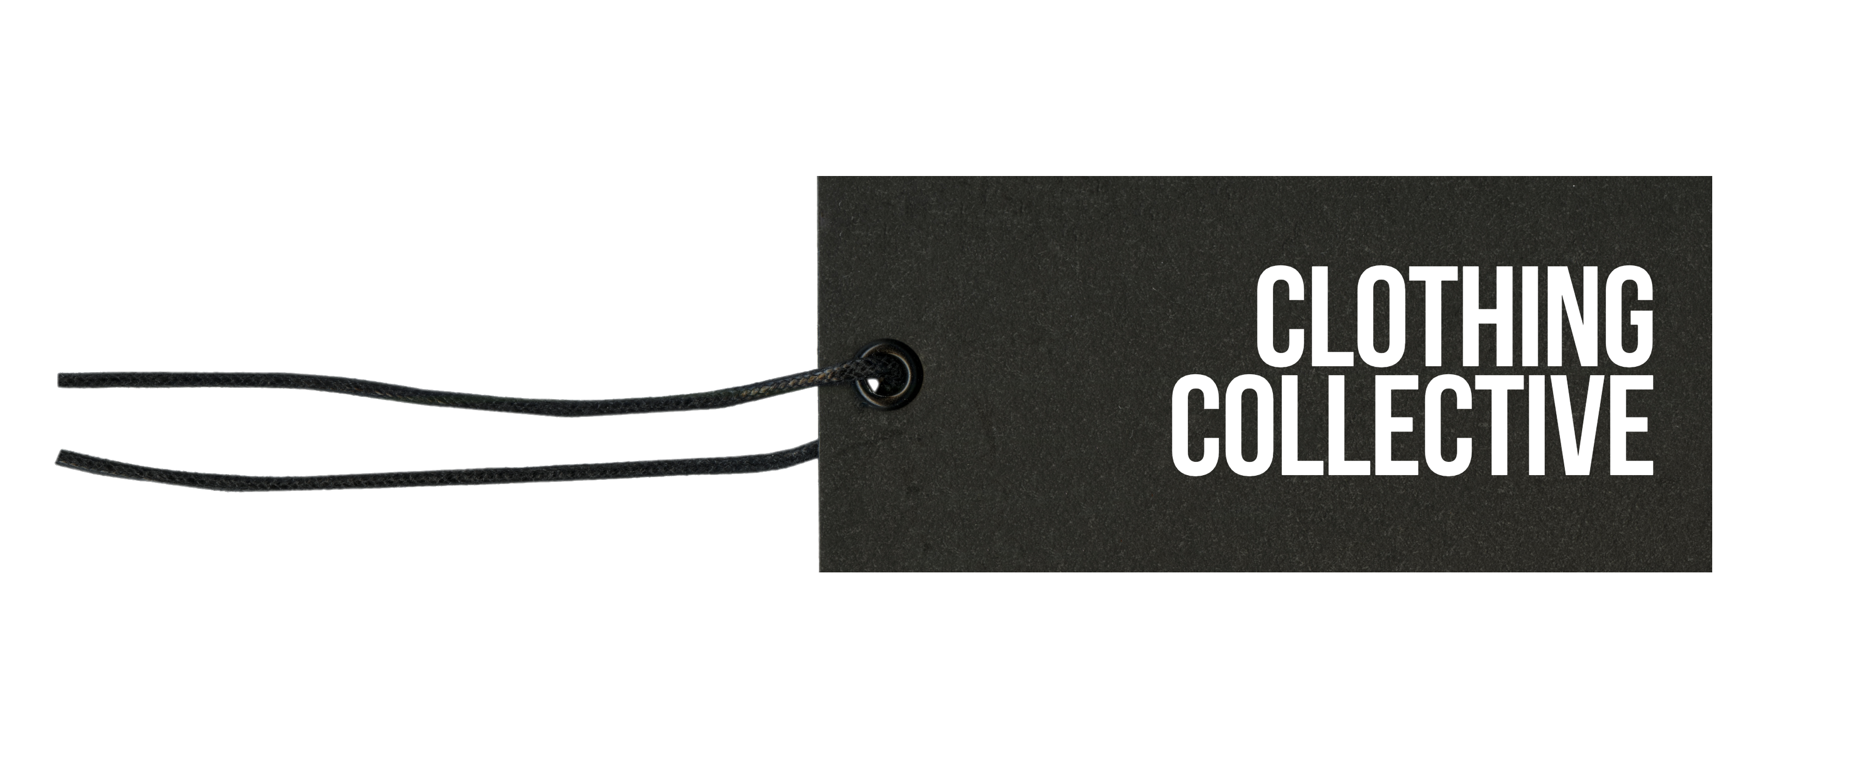

Social Media Policy

**Applicability**

This policy applies to all trustees, other volunteers, employees, contractors, and third-party representatives of the charity. Its requirements should be reflected in other policies and procedures, agreements and contracts, as necessary.

**The Law**

There is no specific UK law but social media is falls within a number of laws such as the Malicious Communications Act, the Communications Act, and the Criminal Justice and Police Act. Under these laws it is illegal to send “indecent” or “grossly offensive” messages, and/or send “threats”, or “false information” with the intention of “causing distress or anxiety” to its receiver or receivers. The Harassment Act also helps to protect social media users.

You should also be mindful of the Data Protection Act and ensure that you do not breach an individual’s right to privacy. Finally, be aware of copyright law and do not post without permission anything that is owned by another person or organisation.

Finally, social media has no national boundaries, so your posts may well be read in other countries.

**Our Spokespeople**

We have a number of spokespeople to represent us. If you’re unsure if you are one or not, you’re not, so don’t.

Even if you do not speak on behalf of Clothing Collective, you are personally responsible for all online content you publish. If you were to post on an issue related to our work, people who know you may think you were speaking on our behalf and those that don’t, may think so too, if you were to use our logo or refer to us in your posts.

**Guidelines**

**Do not breach privacy or security.** Do not post personal information, such as someone’s home address, and never post about individuals without their consent, unlessthere is little if any doubt it would be given. Remember that individuals who may not be fully competent, perhaps due to a disability or illness, such as dementia, may not be able to give consent.

Don’t make it easy for criminals, by posting information that they might use. For example, that the lock on the front door has broken (again), you will be taking a lot of cash to the bank or working late on your own.

**Clearly state your opinions are your own**. If you are not a spokesperson, make clear that your comments, opinions or tweets are your own, so these won’t be interpreted as our position. This statement could appear on your profile. On Twitter, this should be in the ‘Profile’ section, which can be edited under ‘Settings’.

**Appear human.**  Observing certain guidelines does not mean you have to sound like a robot. Speak in the first person; bring your personality to the forefront.

**Write using our ‘tone of voice’.** Where possible, when communicating with the public, media or government, use our ‘tone of voice’.

We are passionate in supporting our community and like a laugh as much as anyone else, but we’re professional, courteous, positive and respect the right of others to hold opinions that are different to ours.

**Abusive Posts.** A troll is someone who intentionally causes upset, harm, or offence by provoking people online.  Be careful not to confuse a troll with someone who is critical and/or upset. There will be people who have valid concerns or have a genuine complaint that may come across as angry and irate. Look at their social media to see they post and how they reply. Trolls often have a profile picture that is an object, rather than a person, or no profile image at all.

People who are abusive are usually trying to provoke a reaction from you, so don’t give them what they want. Besides, you are unlikely to convince them they are wrong. Tweet or post separately to address the issue. You can also adjust your settings to not allow replies, use the relevant abuse reporting system, block them and, if you think they are committing a crime, report them to the police. Here’s a [useful flow chart](https://commscreatives.com/2014/05/29/a-quick-guide-to-answering-people-who-use-social-media-to-talk-to-your-organisation/) on how to respond to different types of posts.

[**Disagreeing**](http://bigthink.com/paul-ratner/how-to-disagree-well-7-of-the-best-and-worst-ways-to-argue)**.** If you disagree with something and feel you should respond, always be courteous and do not personalise your response. Focus on the issue, not the person who wrote the post. If you simply ‘poke someone in the chest’, you won’t get a positive response. And no issue was ever solved without a solution, so offer one.

**Text and Symbols.** Using emoji, ‘lol’ etc can help add humour to a fun post, but don’t use if you are making an important point, as this would trivialise your message. And using multiple exclamations, and lots of capital letters, bold and underling is ‘shouting’, you would not be taken seriously.

**Think first, upload/tweet after**. If something gets online, it stays there for a long time. Tweets now appear in Google search results. So that off-hand tweet or opinionated blog post can all be traced back to you.

**Ask for a second opinion.** Not sure if and how you should tweet or comment on something? Contact David Somervile for advice.

**Be politically neutral.** It is essential that we are not only politically neutral but seen to be. We aim to influence the government and its agencies positively in support of our community and criticising them won’t help us do that. Equally, we treat all recognised political parties with respect and support any of their initiatives that support our own aims, but we do not actively support or promote any individual party.

**Ethics.** We are a politically neutral charity, so appearing to support or endorse (even inadvertently) campains (e.g., smoking, getting drunk) would be inappropriate. Posts should always be respectful of beneficiaries and portray them in a way they would wish to be, and not cause embarrassment, offence or alarm.

**Respect copyright, fair use and other laws**. Using imagery? Make sure you acknowledge the source and observe [copyright laws](https://www.gov.uk/copyright). Images of crowds at events don’t require the approval of each individual, but an image where a limited number of individuals are the subject matter of the image do. For example, an image of a band at a large cultural event, which includes the audience, doesn’t require everyone in the audience’s approval, but a small group of people, where they are clearly the subject of the image would. It is particularly important that you obtain permission, if you wish to use images of children or vulnerable adults.

**Don’t be offensive.** To anyone, for any reason. Two good tests:

* If you wouldn’t say it to their face, don’t say it at all and:
* If you wouldn’t want your mother to read it, don’t write it.

Extremist views, sexism, pornography/distressing or otherwise offensive imagery, racial/ethnic or religious discrimination, homophobia or disparaging comments against any minority group, such as the disabled or mentally ill would not be acceptable, under any circumstances, ever.

**Meaning**

Remember that the majority of our communication is through body language and voice tone/loudness etc, and the amount of written text in social media can be limited, so meaning can easily be lost. What may appear lighthearted and funny to you, may potentially come across very differently on social media.

And take into account potential social and/or cultural differences in your audience who may be more sensitive to particular issues or subjects than the wider population.

**Fundraising**

WE comply with the [Code of Fundraising Practice](https://www.fundraisingregulator.org.uk/code), which applies to fundraising on social media platforms. It outlines both the legal rules that apply to fundraising and the standards designed to ensure that fundraising is open, honest and respectful.

**Politics & Campaigning**

We may campaign for a change in the law, policy or decisions, where such change would support the charity’s purposes, or to ensure that existing laws are observed.

We will at all times remain independent and ensure that any involvement we have with political parties is balanced, and will not support or promote a political party, candidate or politician. We may support specific policies advocated by political parties if it would help us achieve our charitable purposes. However, we will not allow the charity to be used as a vehicle for the expression of the political views of any individual trustee or staff member.

We believe in the democratic right of charities and others to peaceful protest. However, we would neither encourage nor condone any activity that broke the law or caused significant distress or harm to individuals or placed those carrying out the protest at risk of harm to themselves.

**Imagery**

If we use AI generated, stock or digitally enhanced imagery, particularly where the subject may be emotive or challenging, we will ensure that the way in which we do so is not reasonably likely to mislead and, potentially, influence people. For example, we may make our policy on its use publicly available and use watermarks, alt text and/or footnotes and/or explain this in content text. We may not do so where its context and/or content is unlikely to mislead or influence. For example, an image of intergalactic war or use of a stock image on a post about opening hours.

We recognise that AI deep fakes can be difficult to identify but those using our social media will be made aware of the risk. We will not like, share or support in the comments any imagery or content that we reasonably suspect to be fake.

**Moderation of Posts on Our Social Media**

We act as a platform, both online and off, for our community to debate issues that matter to them and we actively encourage diversity of opinion. We believe that open, honest debate can help to address divisions and just because we don’t agree with something, doesn’t necessarily mean that we would remove it. For example, critical comments about our work are rare but, whilst we always respond in a balanced and measured way, we do not remove these, even when we do not necessarily agree with these, subject to the guidelines below.

The community has diversity of views, some strongly held. There is nothing wrong in holding strong views, but that does not automatically make alternative views offensive. In general, as long as a post does not break the law, is a genuine contribution to a debate and is not offensive, we would not usually remove it. Specifically, we will take down any post that falls into the categories below:

* Anything we believe may fall into any of the categories in the section above titled ‘The Law’.
* We would remove any post that contained views that we feel the majority of reasonable people would consider to be offensive.
  + The section ‘Don’t be offensive’ above is not an exhaustive list but does provide guidance on what would normally be considered offensive.
  + The use of ‘swear words’ would normally also be considered offensive.
  + As would derogatory comments about an individual or organisation.
* Any post that is irrelevant to our work and the online conversations being held.

We may also block those posting such material and/or report the issue to the relevant authorities.

**Take Down Process**

* Authority to remove posts has been delegated, as follows:
  + Immediate take-down of posts that are obviously unacceptable – David Somerville
  + Take down of posts that may be unacceptable - David Somerville
* Any request to take down a post is to be managed using our complaints (or other) policy.
* Before a post is taken down, screenshot or otherwise record the post.

**Distribution**

This policy is to be brought to the attention of staff and volunteers on appointment, and relevant elements included in group moderation statements, editorial policies, staff handbook, as appropriate.

**Version Control - Approval and Review**

|  |  |  |  |  |
| --- | --- | --- | --- | --- |
| **Version No** | **Approved By** | **Approval Date** | **Main Changes** | **Review Period** |
| 1.0 | Board | Oct 23 | Initial draft approved | Annually |

**Regulatory Guidance**

Charity Commission: [Managing online risk](https://www.gov.uk/guidance/safeguarding-duties-for-charity-trustees#operating-online).

Charity Commission - [Political activity and campaigning by charities](https://www.gov.uk/guidance/political-activity-and-campaigning-by-charities).

Charity Commission – [Charities and social media](https://www.gov.uk/government/publications/charities-and-social-media/charities-and-social-media).

ICO – Social media privacy settings. <https://ico.org.uk/for-the-public/be-data-aware/social-media-privacy-settings/>

IPO – Copyright notice: digital images, photography and the Internet.

[https://www.gov.uk/government/publications/copyright-notice-digital-images-photographs-and-the-internet/copyright-notice-digital-images-photographs-and-the-internet#](https://www.gov.uk/government/publications/copyright-notice-digital-images-photographs-and-the-internet/copyright-notice-digital-images-photographs-and-the-internet)

IPO – Copyright & GDPR for photographers. <https://ico.org.uk/for-the-public/be-data-aware/social-media-privacy-settings/>

NCSC - [Social media: protecting what you publish](https://www.ncsc.gov.uk/guidance/social-media-protect-what-you-publish).

NCSC - [Social media: how to use it safely](https://www.ncsc.gov.uk/guidance/social-media-how-to-use-it-safely).

Gov.UK - [A guide to the Online Safety Bill](https://www.gov.uk/guidance/a-guide-to-the-online-safety-bill).

**Useful Resources**

[UK Safer Internet Centre](https://saferinternet.org.uk/).

[Digi Safe](https://digisafe.thecatalyst.org.uk/): Step-by-step digital safeguarding guide.

**Young People**

[Facebook](https://www.facebook.com/safety/childsafety/onlinesafety): Your child’s online safety.

[National Youth Agency](https://nya.org.uk/skills/safeguarding-and-risk-management-hub/): Safeguarding & Risk Management Hub.

[NCPCC Learning](https://learning.nspcc.org.uk/child-abuse-and-neglect/online-abuse): Protecting children from online abuse.

[NSPCC Learning](https://learning.nspcc.org.uk/safeguarding-child-protection/social-media-and-online-safety): Social media and online safety.

Date of Issue: 29th April 2025 – Charity Excellence

Registered Charity No: 1178825

5th Floor | 167 -169 Great Portland Street | London | W1W 5PF | 07918 735 319

[info@clothingcollective.org](mailto:info@clothemethankyou.com) [www.clothingcollective.org](http://www.clothingcollective.org)